Wellbeing & Mental Health Vision  To support everyone’s wellbeing and mental health, so that they can be the ‘Best they can Be’, are happy together, resilient, ready to learn and succeed. | Mission Statement  Following Jesus’ footsteps  and inspired by St Robert  Southwell, we work hard,  aim high and treat  everyone with honesty  and gentleness. | Vision Statement  Vision: Aiming for Excellence:  Being The Best We Can Be.
Catholic Life
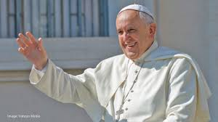
Pope Francis
We continue to pray for Pope Francis who remains in hospital.
Prayer: We thank you for the loving service of Pope Francis and the hope he has inspired in so many in your great mercy.
Have mercy on him in his illness, we pray you will guide the medical staff caring for him. Grant him peace and healing through Christ our Lord. Amen.


March – The Month dedicated to St Joseph
The Church has assigned a special emphasis to each month of the calendar year. For Catholics, March is the month devoted to St. Joseph, the Month of St. Joseph is punctuated by the Solemnity of St. Joseph, on March 19th.St Joseph is the patron saint of workers, families, homes, and a happy death.
St Joseph – Pray for us.

Lent


Lent is a time for us to turn back to God. It is a time to reflect on the choices we make and the way we live our lives, to seek forgiveness for where we have gone wrong, and to draw closer to God. It is a time to pray to fast, and to share what we have with others.
In this Jubilee Year, the call to renew our faith and live differently is even stronger. The Church has dedicated a whole year to considering how we can start anew and restore the balance in our society, so that all people may flourish.
Prayer: Merciful God, open our hearts to your love, as we turn back to you this Lent. Lead us to share this love with one another as we work together to bring about a better world. Amen.


Message
We marked the start of Lent as a Catholic community with our Ash Wednesday service and the distribution of Ashes. Lent is an important time for our community as we prepare to celebrate the risen Lord at Easter.
World Book Day yesterday was a fantastic opportunity to celebrate reading for pleasure, sharing stories and books with one another in school, throughout the day.
Next week, on Thursday 13th March, we have our annual fundraising concert with performances from Mrs Kelly’s musicians and Mrs Headd-McDermott’s Irish dancers.
Next week is British Science week and an opportunity for us to recognise the importance of science both in our curriculum and in our lives.
Triple Charity Fundraiser – Thursday 13th March
Our children are playing their instruments and dancing in this special charity concert next Thursday. Tickets are available from the school office. Unless a child is performing at the concert, they need a ticket to sit in the audience. This is a very special concert which raises money for three charitable groups. The Robert Southwell Foundation which supports the maintenance of our building and supports the costs of running the school. The Friends’ Association who provides extra resources, enrichment experiences and social opportunities for children and families. This year there will also be a collection for St Luke’s Hospice. Some of the musicians performing on Thursday evening will also be playing at St Luke’s on Friday, 14th March. Thank you in advance for your support.

World Book Day
Our amazing children enjoying reading with each other yesterday.
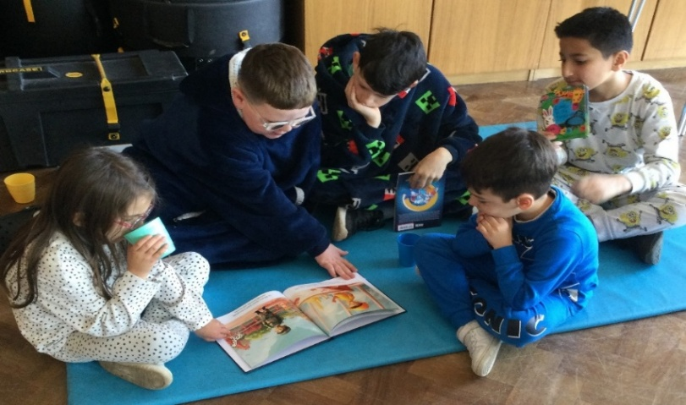
The children enjoyed a reading focused day yesterday and it was wonderful to see the mixture of those dressed in pyjamas and those in book character costumes. The children enjoyed hot chocolate and sharing stories. Thank you to those who sent in photographs reading in different spaces, these will be put together to create a display in the library.

Parent Information - PSHE and SRE
The information meeting for parents was attended by 40 parents on Tuesday evening. There will be an opportunity to ask questions and clarify anything face-to-face next Tuesday, March 11th at 2.15pm in school.

As a school, we believe a strong PSHE curriculum supports wellbeing and helps children in keeping themselves safe and being able to establish positive relationships throughout their childhood, and into their adult lives. It also develops their understanding and awareness of how to keep themselves and others safe. The Ten, Ten programme we use in school is fully endorsed by the diocese and meets the requirements of the National Curriculum.

Upcoming Dates
Date | Time | Event
March Women’s History Month

March Month of St. Joseph

7-16/3 British Science Week
8/3 |  | International Women’s Day
9/3 |  | First Sunday of Lent
12/3 |  | Year 1 to RAF Museum
13/3 |  | Year 4 to Verulamium Museum
13/3 | Afternoon | Nursery Parental Consultations
13/3 | 6.00pm - 9.00pm | Charity Music & Dance Concert  Everyone attending who is not performing must have a ticket for a seat in the audience.  Tickets available from the school office.
18/3- 24/3 |  | Neurodiversity Week
16/3 |  | First Sunday of Lent
17/3 |  | St Patrick’s Day
19/3 |  | Feast of St. Joseph
19/3 |  | Year 1 – Wembley Stadium walk
20/3 | Afternoon | Nursery Parental Consultations
20/3 | 7.00pm | Friends’ Association meeting – all welcome
21/3 |  | World Poetry Day
22/3 |  | World Water Day
Date | Time | Event
23/3 |  | Third Sunday of Lent
25/3 |  | Feast Of Annunciation
25/3 |  | Year 2 trip to Natural History Museum
26/3 |  | Parental consultations – Nursery – Year 6
30/3 |  | Mother’s Day
30/3 |  | Fourth Sunday of Lent
2/4 |  | Year 6 trip to Imperial War Museum
3/4 |  | Friends’ Association Easter Raffle
3/4 |  | Parental Consultations – Reception – Year 6
4/4 |  | Nursery visit to Kingsbury Library
4/4 |  | School closes for Easter break at 2.00pm

Lenten Liturgies
Easter Liturgies – main school hall
Year 1 – Palm Sunday | 9.00am Monday, 31st March
Year 2 – Last Supper | 9.00am Tuesday, 1st April
Year 4 – The Way of the Cross | 9.00am Wednesday, 2nd April
Year 5 – Resurrection | 9.00am Thursday, 24th April

Jubilee 2025 – Being Pilgrims of Hope

May the grace of the Jubilee reawaken in us, Pilgrims of Hope, a yearning for the treasures of heaven. May that same grace spread the joy and peace of our Redeemer throughout the earth. To you our God, eternally blessed,

